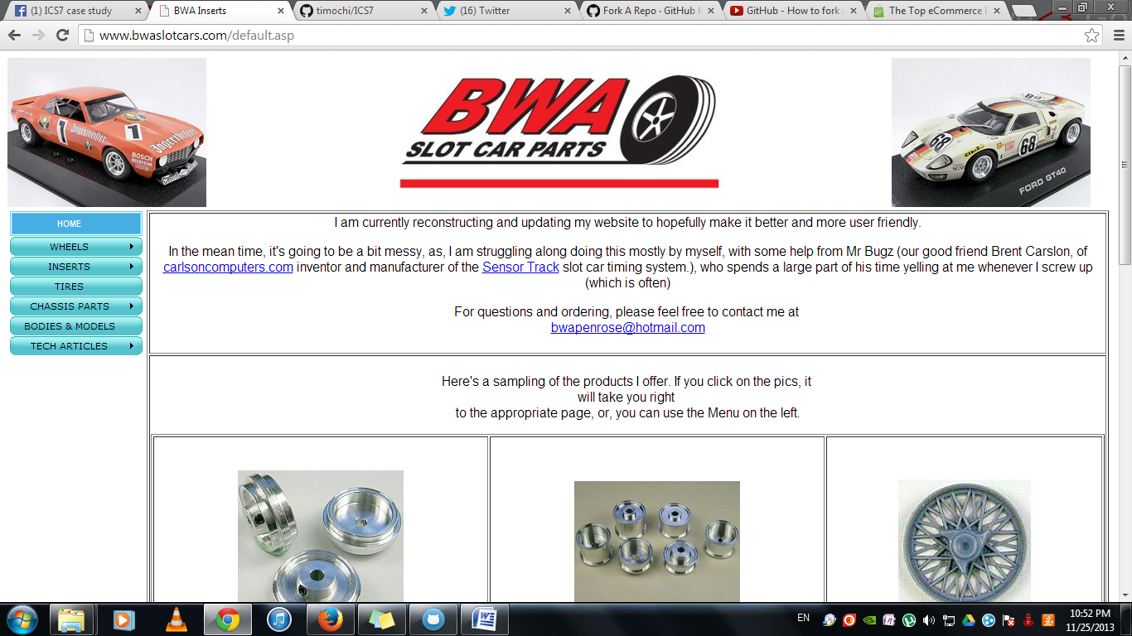

1. **BWA SLOT CAR PARTS**

www.bwaslotcars.com

**Design Flaws**

1. Plain background
2. Doesn’t make good use of space

**Lacking Functionalities**

1. “Add to cart” feature
2. Online payment
3. Individual pages for each product
4. “Buy now” button for each product page.

**Possible Improvements**

1. Fixed size for each cell.
2. Place navigations on top
3. Fix text-alignment
4. Change background